Election Mastery Assignment
Reflection Log
Stefan S
CSE 2140 2nd Language Programming
(Election.java)
How has your program changed from planning to coding to now? Explain.
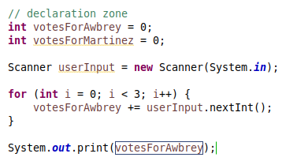
Earliest working version of the assignment. Incredibly simple, most of the complexity will come from printing the right text for the user.

Switch case was incredibly easy to implement. No errors.
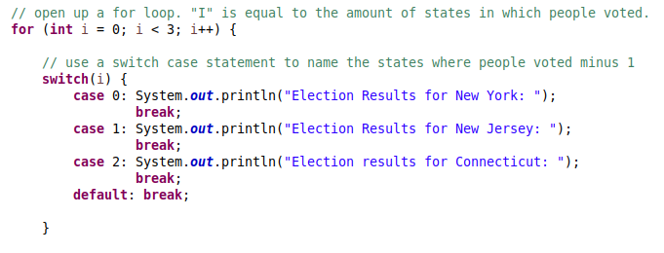

Final program:
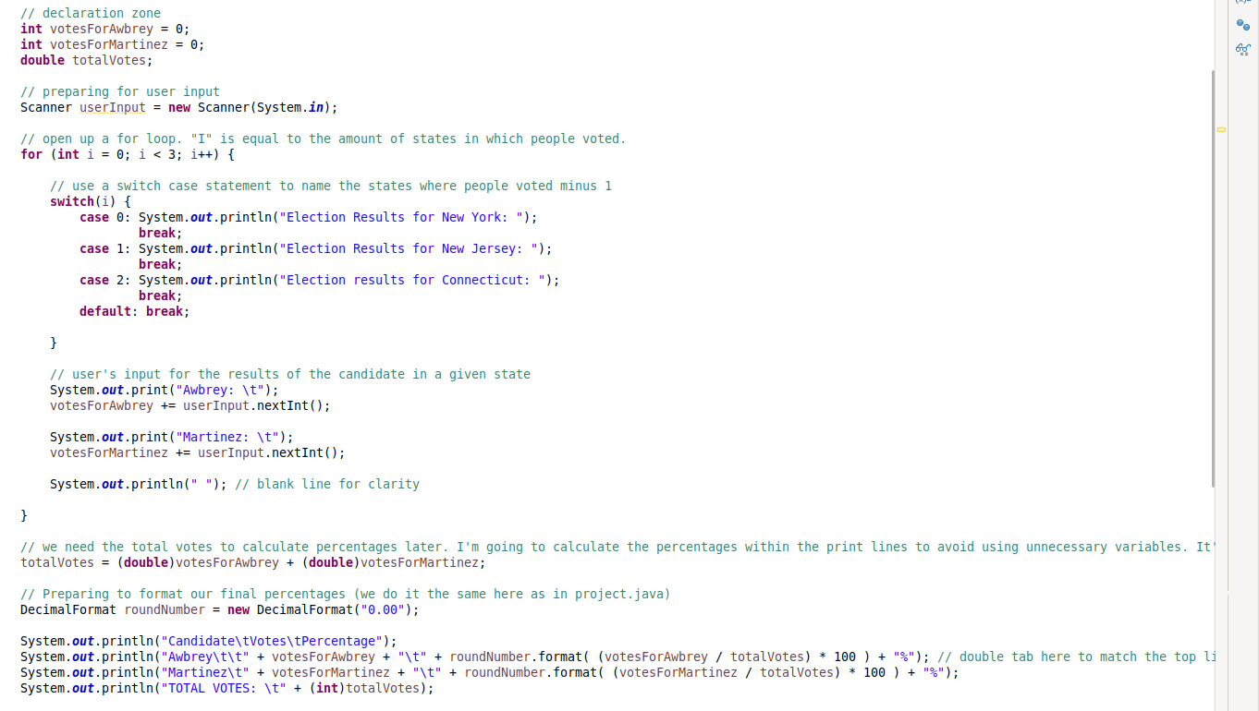
What I’ve found in making this program was that it was extremely straightforward once I had my IPO sorted. The IPO took me some time, but once I had that sorted the actual programming had very few errors.

